Application form for Sponsors & Exhibitor
Please complete this form and return to the IVEC 2019 Secretary. (ivec2019@ivec2019.org)
- Registering company and person in charge
Name of Company (used on conference program book and website)
Address
Telephone |  | Website
Country |  | Business License No.  (For Korean Company Only)
Contact Person Name |  | Job Title / Depart.
E-mail
- Application (Please check √ for your choice)
 | For Korean Company | For Foreign Company
Platinum | □ 5,000,000 WON | □ $5,000
Gold | □ 3,000,000 WON | □ $3,000
Silver | □ 2,000,000 WON | □ $2,000
Bronze | □ 1,000,000 WON | □ $1,000
Only for the  Exhibition Booth | □ 1,500,000 WON | □ $1,500
* Preferred booth No. | □ No. S1 □ No. S2 □ No. S3 □ No. 1 □ No. 2 □ No. 3 □ No. 4 □ No. 5 □ No. 6 □ No. 7  □ No. 8 □ No. 9 □ No. 10 □ No. 11 □ No. 12 □ No. 13 □ No. 14 □ No. 15  ※ The application for the Booth Exhibition has been closed. No more available booth.
- Payment Method (Bank Transfer Only)
Account Holder | Korean Institute of Electromagnetic Engineering and Science (KIEES)  (KOR) (사)한국전자파학회
Account Number | 208-017491-01-223
Bank Name | INDUSTRIAL BANK OF KOREA
SWIFT Code | IBKOKRSE
Bank Address | 50, Eulgiro 2-ga, Jung-gu, Seoul, Korea
※ Terms of payment : Receipt will be issued by 「Korean Institute of Electromagnetic Engineering and Science (KIEES)」
after confirmation of the sponsoring/exhibition.
※ Cancellation policy : After payment, there will be no refund.
※ Signing of the Application form for Sponsors and Exhibitors – IVEC 2019 implies acceptance of the terms of payment and the cancellation policy as mentioned above.
※ Application deadline is March 31, 2019. (can be closed early)
Date: | YYYY. MM. DD
Signature:

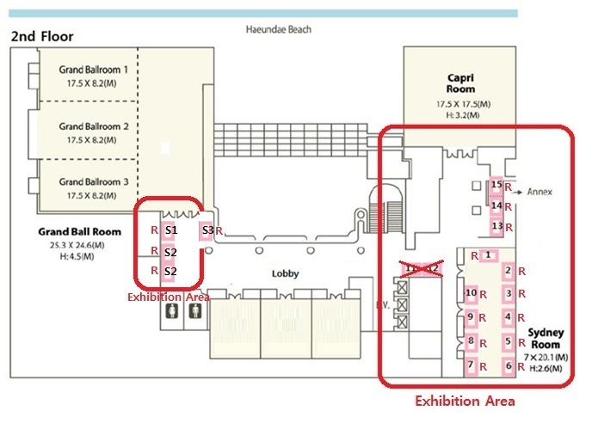

※ Note that the booth layout is subject to change depending on circumstances.
※ “R”: had already been reserved.

